Day #2 – What does it mean to have a Government Contract

Welcome to Day #2 of 'Govcon for Dummies' training program.

Yesterday you learned what was a government contract and the types of things that they buy.

In today’s video we are demonstrating what does it mean to have a government contract. I hired a professional videographer to create this whiteboard animation to help explain my case and point better.

Hope you enjoy the video animation we created for you.

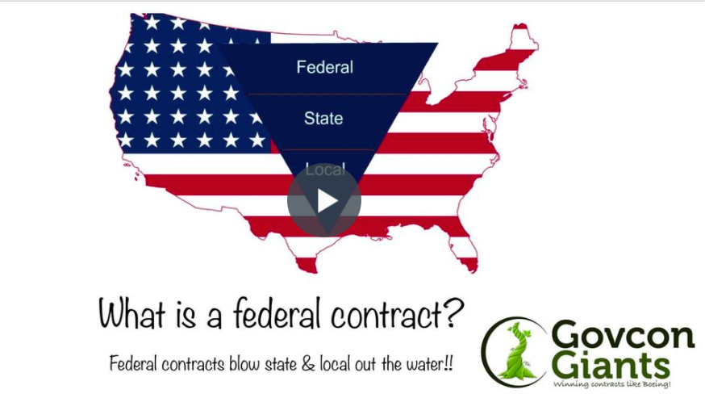

In Today’s HW assignment we will be looking at codes for the potential business that you are considering starting. Or if you have business we will show you how identify those codes for the government.

So make sure you don’t miss the lesson - as it is critical to forming the foundation of understanding.

Watch the Whiteboard Animation video now!

Even if you think you know what it is. You don’t

Thanks,
Eric Coffie

